1. **Retrieve all columns for sales made in a specific branch (e.g., Branch 'A').**

SELECT * FROM transactions

WHERE Branch = 'A';

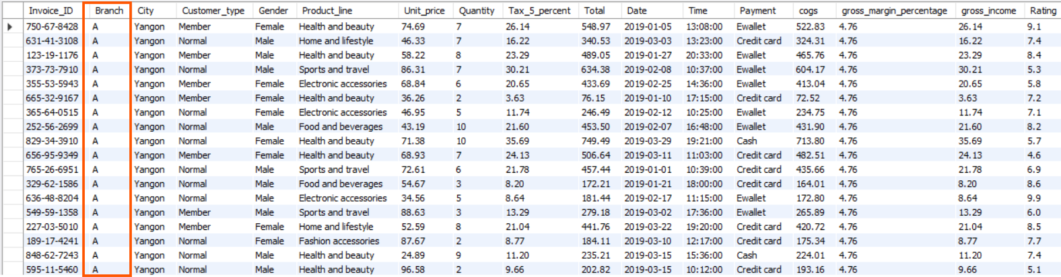

1. **Find the total sales for each product line.**

SELECT

Product_line, ROUND(SUM(Total), 2) AS total_sales

FROM

transactions

GROUP BY Product_line;

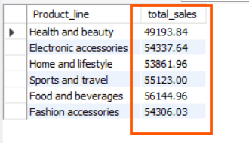

1. **List all sales transactions where the payment method was 'Cash'.**

SELECT * FROM transactions

where Payment='Cash';

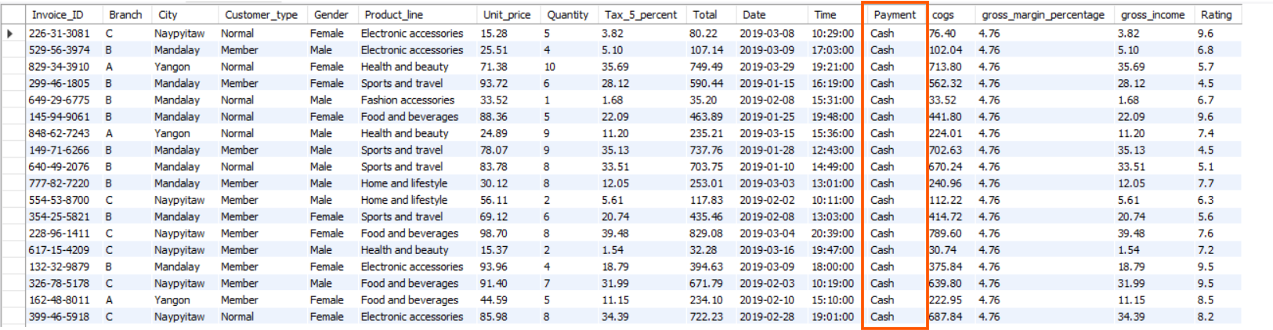

**4. Calculate the total gross income generated in each city.**

SELECT City,

round(sum(gross_income),2) AS total_gross_income

FROM

transactions

GROUP BY

City;

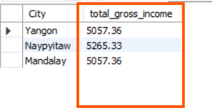

**5.Find the average rating given by customers in each branch.**

SELECT Branch,

round(avg(rating),2) AS average_rating

FROM

transactions

GROUP BY Branch;

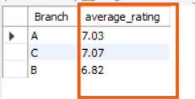

1. **Determine the total quantity of each product line sold.**

SELECT Product_line,

sum(quantity) AS total_quantity_sold

FROM

transactions

GROUP BY Product_line;

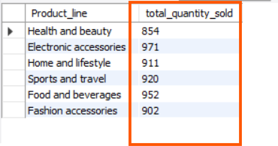

1. **List the top 5 products by unit price.**

SELECT Product_line, Unit_price

FROM transactions

ORDER BY Unit_price LIMIT 5;

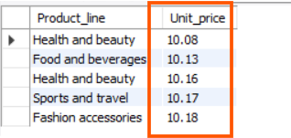

**8.Find sales transactions with a gross income greater than 30.**

SELECT * FROM transactions

WHERE gross_income > 30;

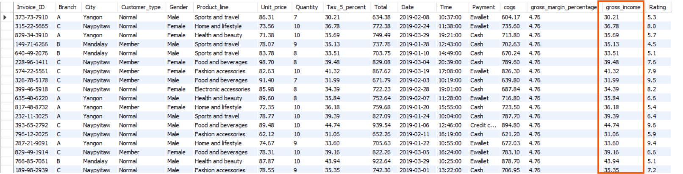

**9. Retrieve sales transactions that occurred on weekends.**

SELECT *,

CASE

WHEN DAYOFWEEK(Date) = 1 THEN 'Sunday'

WHEN DAYOFWEEK(Date) = 7 THEN 'saturday'

END AS weekday_name

FROM

transactions

WHERE DAYOFWEEK(Date) IN (1 , 7);

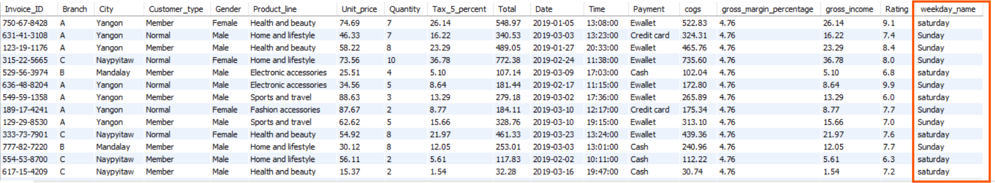

**10. Calculate the total sales and gross income for each month.**

SELECT

DATE_FORMAT(STR_TO_DATE(Date, '%Y-%m-%d'), '%Y-%m') AS month,

ROUND(SUM(Total), 2) AS total_sales,

ROUND(SUM(gross_income), 2) AS total_gross_income

FROM

transactions

GROUP BY

DATE_FORMAT(STR_TO_DATE(Date, '%Y-%m-%d'), '%Y-%m’)

ORDER BY month;

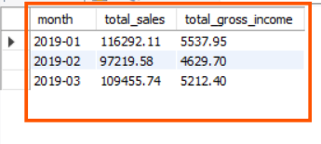

**11. Find the number of sales transactions that occurred after 6 PM.**

SELECT COUNT(*) AS num_transactions_after_6pm

FROM transactions

WHERE TIME(Time) > '18:00:00';

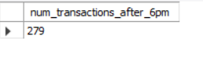

**12. List the sales transactions that have a higher total than the average total of all transactions.**

select * from transactions

where Total > (SELECT avg(Total) from transactions);

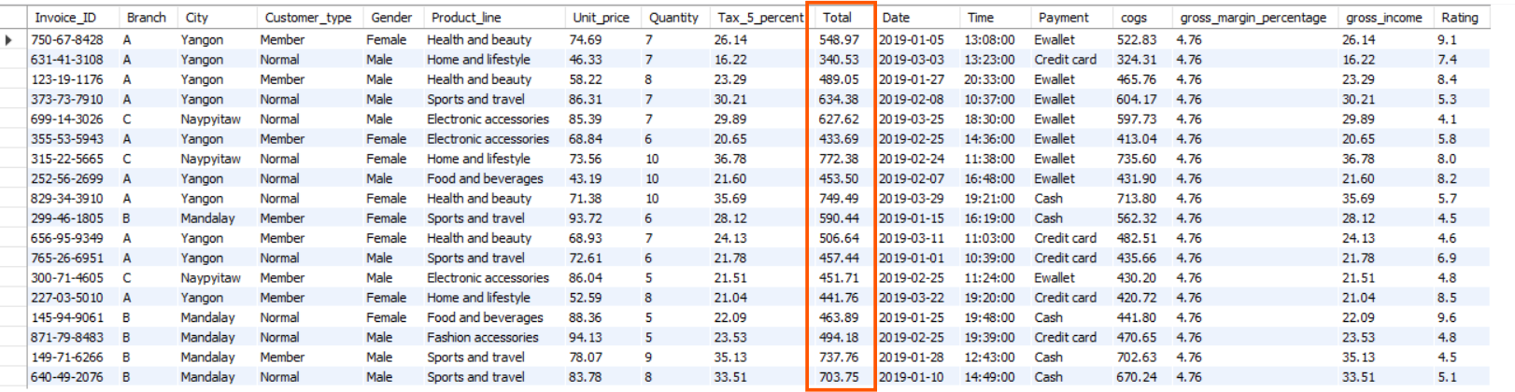

**13. Calculate the cumulative gross income for each branch by date.**

SELECT Branch, Date,

gross_income,

round(sum(gross_income) OVER (PARTITION BY Branch ORDER BY Date),2)

AS cumulative_gross_income

FROM

transactions

ORDER BY Branch, Date;

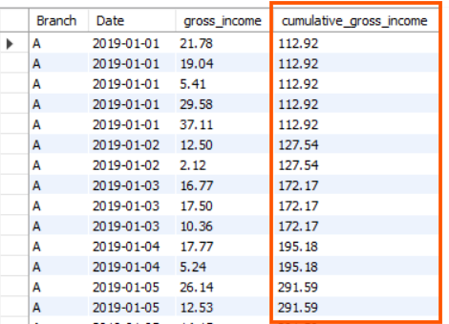

**14. Find the total cogs for each customer type in each city.**

SELECT city,

Customer_type,

round(sum(cogs), 2) AS total_cogs

FROM

transactions

GROUP BY

Customer_type,

City;

